CLOUD STORAGE USING BLOCKCHAIN

Submitted partial fulfillment of the requirements of the
University of Mumbai
For the Degree of
Third Year (SEM VI) of Computer Engineering

Submitted By:

KAPIL UGALE (50)

Under Guidance of
Prof. Shagufta Khanum

Department of Computer Engineering


Smt. Indira Gandhi College of Engineering

Affiliated to University of Mumbai (2024-2025)

APPROVAL CERTIFICATE

Submitted by Kapil Ugale (Roll No: 50) in partial fulfilment of the requirements for the award of the degree of Bachelor of Engineering in Computer Engineering, Semester VI, under the University of Mumbai, has been examined and approved by the department. The project work is found to be satisfactory and meets the academic requirements as per the university guidelines.

External Examiner Prof. Shagufta Khanum
Internal Guide

Dr. K. T. Patil Dr. Sunil Chavan
Head of Department Principal

Date:
Place: Ghansoli, Navi Mumbai

DECLARATION
We declare that this written submission represents our own ideas in our own words and where others ideas or words have been included, we have adequately cited and referenced the original sources. We also declare that we have adhered to all principles of academic honesty and integrity and have not misrepresented or fabricated or falsified any act/data/source in our submission .We understand that any violation of the above will be cause for disciplinary action by the Institute and can also evoke penal action from the sources which have thus not been properly cited or from whom proper permission has not been taken when needed.

KAPIL UGALE (50

ABSTRACT

Cloud storage, concerns around data security, privacy, and integrity have become increasingly significant. Traditional cloud storage systems often rely on centralized servers, making them vulnerable to data breaches, unauthorized access, and single points of failure. To address these challenges, this study explores the integration of blockchain technology with cloud storage to enhance data security, transparency, and reliability.
Blockchain, known for its decentralized and tamper-resistant architecture, offers a promising solution for secure data management. In this project, we examine how blockchain can be used to decentralize cloud storage, ensuring that data is encrypted, distributed across multiple nodes, and accessible only through secure consensus mechanisms. Smart contracts are also utilized to automate access control and data sharing without the need for intermediaries.
The results suggest that blockchain-based cloud storage can significantly improve data confidentiality, integrity, and resilience against attacks. This research highlights the potential of combining cloud storage with blockchain to build a more secure and trustworthy digital infrastructure.

INDEX

Chapter No. | Contents | Page No.
 | Abstract | 4
1 | Introduction | 6
 | 1.1ProblemStatement | 7
 | 1.2Objectives | 7
 | 1.3Scope | 9
 | 1.4Methodology | 9
 | 1.5ReportOrganization | 11
2 | Review & Literature | 12
 | 2.1Survey Of Existing Paper | 13
 | 2.2LimitationsOfExistingSystem | 13
3 | Planning And Formulation | 18
 | 3.1Feasibility Study | 19
 | 3.2HardwareRequirement | 19
 | 3.3SoftwareRequirement | 19
4 | System Analysis | 21
 | 4.1DataAnalysis | 22
 | 4.2Functional Analysis | 22
 | 4.3Non-FunctionalAnalysis | 23
5 | Proposed System | 24
 | 5.1SystemArchitecture | 25
 | 5.2SystemDesignFlowchart | 28
6 | Implementation | 30
 | 6.1Algorithm | 31
7 | Results | 32
 | 7.1Output | 33
8 | Conclusion | 38
 | 8.1Conclusion | 39
 | 8.2FutureScope | 40
 | References | 41
 | Acknowledgement | 42

CHAPTER 1 INTRODUCTION

INTRODUCTION

  - PROBLEM STATEMENT:

In the rapidly evolving digital landscape, the need for secure, private, and reliable data storage has become more critical than ever. Traditional cloud storage providers, while convenient, operate under a centralized architecture that inherently suffers from vulnerabilities such as data breaches, unauthorized access, and systemic failures. These issues highlight the importance of exploring alternative storage paradigms that prioritize user control, data integrity, and resilience.
This project introduces a Decentralized File Storage System that integrates Blockchain technology with the InterPlanetary File System (IPFS) to offer a novel solution to the limitations of conventional cloud storage. By combining the distributed nature of IPFS with the immutable ledger capabilities of blockchain, the system ensures that files are securely stored, verifiably unaltered, and entirely under the user's control.
Through a self-hosted infrastructure, this project eliminates dependence on centralized entities, mitigates risks associated with data tampering and service outages, and promotes transparency in file storage operations. By enabling users to store files across a peer-to-peer network and anchoring metadata on a blockchain, the system achieves a high degree of fault tolerance, security, and auditability—principles that are foundational to the future of decentralized technologies.
This report delves into the design, implementation, and significance of this system, highlighting its ability to redefine file storage through decentralization, user empowerment, and technological innovation.

1.2. OBJECTIVES:
1.2.1 Primary Objectives
1. To Develop a Secure and Decentralized File Storage System
- Implement IPFS (Interplanetary File System) for decentralized file storage.
- Use blockchain technology to maintain an immutable record of file metadata.
- Ensure data integrity and tamper-proof file tracking.
2. To Provide User Authentication and Access Control
- Develop a secure login/signup system using bcrypt password hashing.
- Implement session management to restrict unauthorized access.
- Assign 1GB storage limit per user with real-time tracking.
3. To Enable Efficient File Upload and Download
- Allow users to upload files to IPFS and store metadata in blockchain.
- Provide a download feature using IPFS hashes.
- Ensure duplicate file handling (same file = same hash).

1.2.2 Technical Objectives
1. To Integrate Blockchain for Transparency
- Design a custom blockchain to store file metadata (filename, IPFS hash, user ID).
- Ensure immutability—once stored, data cannot be altered.
2 To Implement IPFS for Decentralized Storage
- Set up a local IPFS node for file storage.
- Use content addressing (CIDs) to uniquely identify files.
- Ensure pinning mechanism to prevent file loss.
3 To Design a Reliable Database System
- Use MySQL to store user details and file metadata.
- Track user storage usage and enforce limits.
- Optimize queries for fast retrieval of user files.
1.2.3 Security and Performance Objectives
1. To Ensure Data Security
- Encrypt passwords using bcrypt hashing.
- Prevent malicious file uploads using secure filename.
- Secure user sessions to prevent unauthorized access.
2. To Optimize System Performance
- Handle large file uploads efficiently (future: chunking support).
- Ensure fast file retrieval from IPFS.
- Maintain scalability for a growing number of users.
1.2.4 Future Enhancement Objectives
1. To Add Advanced Features
- File sharing between users via shareable links.
- End-to-end encryption for enhanced privacy.
- Version control for uploaded files.
2. To Improve Scalability
- Migrate from a local blockchain to a public blockchain (Ethereum, Solana) if needed.
- Implement load balancing for high-traffic scenarios.
3. To Enhance User Experience
- Add search functionality for files.
- Support mobile-friendly UI.
- Provide detailed analytics on storage usage.
1.2.5 Educational Objectives
- To understand decentralized storage concepts (IPFS).
- To learn blockchain integration for real-world applications.
- To explore secure authentication and database management.

  - SCOPE:
The scope of this project encompasses the development and deployment of a decentralized file storage platform that prioritizes data integrity, user ownership, and censorship resistance. The system is intended to serve as a secure alternative to traditional cloud services, focusing on small to medium-sized storage needs with an initial 1GB free storage limit per user.
Key areas covered within the scope include:
- File Storage via IPFS: Ensuring decentralized, redundant, and peer-to-peer storage of user files.
- Blockchain-based Metadata Management: Recording file hashes, timestamps, and ownership information immutably on a blockchain.
- User Authentication: Implementing secure user registration and login using bcrypt-hashed passwords and encrypted sessions.
- Data Integrity Verification: Allowing users to verify file authenticity through blockchain-stored metadata.
- Web Interface: Providing a user-friendly interface for uploading, retrieving, and managing files.
- Backend System: Designing and building a robust backend using Python (Flask) and MySQL to handle user data and system operations.

  - METHODOLOGY:

The development of this project follows a modular and iterative approach, structured into the following phases:

1. Requirement Analysis
- Identified the limitations of existing centralized storage platforms.
- Defined core objectives such as decentralization, data integrity, and user control.

2. System Design
- Designed the system architecture combining three main components:
  - IPFS for distributed file storage.
  - A custom Python-based blockchain for storing file metadata.
  - A backend service using Flask and MySQL for user management and interactions.
- Outlined database schema, user flows, and blockchain structure (blocks, hash function, proof-of-work).

3. Development
- Implemented user registration and login modules with bcrypt-based password hashing.
- Developed the blockchain logic for recording file hashes along with metadata like timestamps and ownership.
- Integrated IPFS nodes to handle file uploads and retrievals.
- Built REST APIs for file operations and blockchain interactions using Flask.
- Designed a web-based frontend for user interaction.

4. Testing & Validation
- Performed unit testing for blockchain integrity, file upload/retrieval, and user authentication.
- Verified successful file hashing and tamper-detection using the blockchain ledger.
- Simulated multiple user interactions to test system performance and IPFS redundancy.

5. Deployment & Documentation
- Deployed the system on a local or cloud server for demonstration.
- Documented the installation steps, API endpoints, and system functionality.

  - REPORT ORGANIZATION:

- Chapter 1: This chapter presents the Introduction to the project, including the background, motivation, and objectives of developing a decentralized cloud storage system using Blockchain and IPFS.

- Chapter 2: Here, we describe the Project Planning and Formulation, explaining the use of the Prototype Model, its relevance to our project, and how we adopted and worked around this model during development.

- Chapter 3: This chapter covers the Hardware and Software Requirements needed for the system. It includes a detailed list of tools, libraries, and environments necessary to build and deploy the project.

- Chapter 4: In this section, the Proposed System is explained in detail. It includes the architectural design, working of different modules, data flow, control flow, and overall system workflow.

- Chapter 5: This chapter focuses on the Implementation, showcasing how various components were developed and integrated. It also includes screenshots of the working project interface.

- Chapter 6: This section presents the Results, displaying the output of the system and analyzing the performance and effectiveness of the implemented model.

- Chapter 7: The final chapter provides the Conclusion and Future Scope, summarizing the project’s achievements and outlining potential enhancements and directions for future work.

CHAPTER 2

REVIEW & LITERATURE

REVIEW & LITERATURE

  - Survey Of Existing Paper:
Existing System
In traditional cloud storage systems, data is stored on centralized servers owned and operated by large corporations such as Google, Amazon, Microsoft, and Dropbox. While these platforms offer user-friendly services and scalable storage, they come with significant drawbacks related to privacy, transparency, and control. Users are unaware of how their data is managed, where it is stored, and whether it is accessed or used for commercial gain by service providers.
Most existing systems do not employ decentralized technologies or smart contracts, which limits transparency and user autonomy. Additionally, many lack peer-to-peer networking, creating a single point of failure and vulnerability to data loss or breaches. Centralized systems also do not guarantee the privacy of transactions, and users often store data on personal offline storage devices as a backup due to distrust in cloud-based solutions.
Furthermore, existing encryption mechanisms in several research works are either outdated or not robust enough to fully secure data in cloud environments. There is a lack of clear, enforceable privacy policies in most prior proposals. While some systems use basic encryption, they are still vulnerable to hacking, data tampering, or unauthorized access. Modern users demand stronger encryption methods, higher transparency in data handling, and complete control over their digital assets.

Proposed System
This project proposes a decentralized cloud storage system using Blockchain and IPFS (InterPlanetary File System) that addresses the limitations of traditional cloud services. Unlike conventional systems, the proposed architecture distributes data across a decentralized peer-to-peer network, enhancing both security and availability.
In this system, user data is first split into multiple shards (data blocks) based on the number of nodes available in the IPFS network. Each shard is individually hash-encrypted to ensure that even if a node stores a part of the data, it cannot read or misuse it. This continues until the entire data is securely encrypted and distributed.
The key innovation lies in integrating smart contracts—self-executing protocols that define the terms and conditions of data storage between the user and the system. These contracts ensure that the user is informed about what data is stored, where it is stored, and what cost is incurred for storage. This eliminates ambiguity and builds trust between users and service providers.
The blockchain component records file metadata, including file hash, timestamp, and user identity, creating an immutable and verifiable log of all transactions. Tools like Ganache are used to simulate and monitor blockchain activity, ensuring transparency throughout the process.
For the decentralized storage layer, IPFS is used to host encrypted shards of data across multiple nodes, much like a BitTorrent system. The address and content hash of each file are recorded on the blockchain, enabling secure retrieval and verification of file integrity.
The frontend of this system is developed using React, offering a clean and interactive user interface. The backend is built with Flask (Python) and MySQL to handle user authentication, file management, and blockchain communication. User credentials are secured using bcrypt hashing, adding another layer of security to the platform.

In summary, the proposed system ensures:
- Complete user control over data
- Transparent storage costs and access
- Strong encryption and privacy
- Decentralized, fault-tolerant file storage
- Tamper-proof logs via blockchain

2.2 Review of Existing Systems / Technologies
Below are some key technologies and systems that have influenced the development of decentralized file storage and blockchain integration:

- InterPlanetary File System (IPFS) – Juan Benet (2014)
Technology Used: Peer-to-Peer File Sharing
Overview:
IPFS is a protocol designed to create a distributed and decentralized method of storing and sharing files. It uses content-addressing to uniquely identify each file and its versions. IPFS eliminates the need for a central server by allowing nodes in the network to share and fetch files directly.
Advantages:
- No central point of failure.
- Efficient file retrieval using content hashes.
- Redundancy through distributed nodes.
Limitations:
- Does not offer built-in encryption or user authentication.
- File permanence depends on pinning; data can be lost if not pinned.
Relevance to Project:
Our system uses IPFS to store files in a distributed manner and addresses its limitations by adding blockchain for metadata tracking and user-level access control.

Filecoin – Protocol Labs (2020)
Technology Used: Blockchain + IPFS (Incentivized Storage)
Overview:
Filecoin is a decentralized storage network built on top of IPFS. It introduces a token-based incentive mechanism that rewards users for renting out storage space and storing files. Users pay in FIL (Filecoin's cryptocurrency) to store and retrieve files.
Advantages:
- Incentivized storage via cryptocurrency.
- Reliable file storage with proof of replication and proof of space-time.
- Builds on IPFS for file storage.
Limitations:
- Requires cryptocurrency (FIL) for transactions.
- Complex for small-scale users or academic projects.
- Heavier infrastructure requirement.

Relevance to Project:
While our system does not use an economic model, it draws inspiration from Filecoin’s use of blockchain for proof of storage and file traceability. Instead of incentives, our project focuses on free storage limits, user control, and transparency.

2.3 Comparative Analysis Table
The following table provides a comparison between existing decentralized storage systems and how they differ from the proposed system in this project.

System / Paper | Technology Used | Advantages | Limitations | Relevance to Project
IPFS (2014) | Peer-to-Peer File Sharing | Efficient content addressing, No central server, Fast file access | No native encryption or access control, Files may be lost without pinning | Forms the core of our storage layer; we enhance it by adding encryption, smart contracts, and blockchain-based metadata tracking.
Filecoin (2020) | IPFS + Blockchain + Incentives | Proof-of-storage, Incentivized system, Redundancy and replication | Requires FIL token, High setup complexity, Not ideal for academic or small-scale systems | Inspired decentralized storage design, but our system removes crypto dependency and offers free storage up to 1GB.
Storj | Sharded Encrypted Storage + Blockchain | End-to-end encryption, Fast decentralized network, File redundancy | Requires tokens (STORJ), Partial centralization in metadata handling | We adopt secure encryption and sharding ideas while improving user control and removing the token-based economic layer.
Sia | Blockchain + Smart Contracts | Smart contract-based SLA, Affordable pricing, Decentralized file sharding | Requires Siacoin, Complex integration, Not beginner-friendly | Our project uses smart contract concepts without adding cryptocurrency overhead, making it lightweight and educational.
Swarm (Ethereum) | Ethereum + Incentivized Storage | Fully decentralized, Integrated with Ethereum ecosystem, Data availability through incentives | High gas fees, Dependency on ETH, Complexity in deployment | Conceptually aligns with our blockchain integration, but our solution is cost-free and more suitable for student and academic use cases.
Traditional Cloud (Google Drive, Dropbox, etc.) | Centralized Cloud Storage | Easy to use, Accessible, Large-scale infrastructure | Complete central control, Lack of transparency, Risk of data misuse | Highlights the need for decentralized, transparent alternatives—our system gives data ownership back to the user.
Research Paper: “Decentralized Cloud Storage Using IPFS and Blockchain” (IEEE, 2021) | Blockchain + IPFS | Describes integration of decentralized technologies, Promotes user autonomy | Lacks authentication mechanisms, No encryption for files in IPFS | Our project improves upon this by adding encrypted sessions, bcrypt-based authentication, and a more secure architecture overall.
Our Proposed System | IPFS + Blockchain + Flask + MySQL | Decentralized, Transparent, Tamper-proof metadata, Free 1GB limit, Encrypted sessions | Limited by hardware resources of self-hosting, No native incentivization yet | Designed for scalability, education, and user empowerment with secure and transparent file storage through modern decentralized technologies.

CHAPTER 3

PLANNING AND FORMULATION

PLANNING AND FORMULATION
  - Feasibility Study:
The proposed project, “Cloud Storage Using Blockchain and IPFS,” is highly feasible in terms of technical, operational, economic, legal, and time-based factors. Technically, the project utilizes open-source and widely supported technologies such as IPFS, Flask, Python, MySQL, and a custom blockchain, ensuring ease of implementation and scalability. Operationally, it offers a user-friendly interface that empowers users with full control over their data without relying on centralized servers. Economically, the system is cost-effective as it requires no licensing fees and can be hosted on local or low-cost infrastructure. Legally, the use of open-source tools and the absence of personal data collection or proprietary content ensures compliance with standard legal guidelines. Finally, the project can be developed and deployed within a typical academic semester, making it suitable for educational and small-scale production use.

  - Hardware Requirements:

Component | Minimum Requirement | Recommended Specification
Processor (CPU) | Dual-core (Intel i3 / AMD equivalent) | Quad-core (Intel i5 or higher)
RAM | 4 GB | 8 GB or higher
Hard Disk / SSD | 50 GB free space | 100+ GB SSD for better performance
Network Connection | Stable Internet (for IPFS node interaction) | Broadband / Fiber-optic internet connection
Graphics | Integrated Graphics (not GPU-intensive project) | Integrated or basic dedicated GPU (optional)
Peripheral Devices | Keyboard, Mouse, Display Monitor | Standard Input/Output Devices

  - Software Requirements:

Software | Description / Purpose | Version / Notes
Operating System | Platform to run the development environment | Windows 10/11, Ubuntu 20.04+ or MacOS
Python | Backend development, blockchain logic, API handling | Python 3.8 or above
Flask | Web framework for backend server and API routing | Flask 2.x
MySQL / MariaDB | Relational database to store user accounts and metadata | MySQL 8.x or MariaDB 10.x
IPFS (Go / Desktop version) | Decentralized file storage system | IPFS Desktop App or Go-IPFS (latest)
Bcrypt | Secure password hashing | bcrypt Python library
Postman / REST Client | API testing and validation | Latest version
Ganache (Optional) | For testing smart contract interactions (if using Ethereum) | Ganache GUI or CLI
ReactJS (Optional) | Frontend development (if used for UI) | React 17+
VS Code / PyCharm | Code editor or IDE | Any modern version
Browser (Chrome/Firefox) | For accessing the web interface | Latest version

CHAPTER 4
SYSTEM ANALYSIS

SYSTEM ANALYSIS

1. Data Collection
- Dataset Description: The analysis is based on a dataset of Amazon reviews, including textual feedback, star ratings, and metadata (e.g., product categories, timestamps).
- Data Sources: Data was collected from the Amazon product review section, utilizing APIs or web scraping techniques to gather a representative sample of reviews across various product categories.
2. Data Preprocessing
- Text Cleaning: The raw review text underwent preprocessing to remove noise. Steps included:
  - Lowercasing all text
  - Eliminating stop words
  - Tokenization (breaking text into individual words or phrases)
- Handling Missing Values: Any missing or incomplete data points were identified and addressed. Strategies included imputation for missing ratings and removal of incomplete reviews.
  - Functional Analysis:

Decentralized Data Storage
Function: Store data across multiple nodes (peers) instead of centralized servers.
Benefit: Reduces single points of failure and increases data redundancy.
Implementation: Files are split into encrypted chunks and distributed using protocols like IPFS (InterPlanetary File System) or similar decentralized networks.
- Blockchain-Based Access Control
Function: Manage permissions using smart contracts.
Benefit: Ensures only authorized users can access, modify, or share data.
Implementation: Smart contracts define who can read/write specific data, using public/private key cryptography.

Immutable Audit Trail
Function: Record every access and change in data on the blockchain.
Benefit: Provides transparency, traceability, and accountability.
Implementation: Each transaction (e.g., upload, access request) is logged immutably on the blockchain.

  - Non-Functional Analysis:

1. Security
- Description: The system must guarantee data confidentiality, integrity, and availability.
- Mechanisms:
  - End-to-end encryption for data confidentiality.
  - Blockchain immutability to prevent data tampering.
  - Role-based access control via smart contracts.
- Goal: Protect against unauthorized access, data breaches, and insider threats.

2. Scalability
- Description: The system must handle a growing number of users, data, and transactions.
- Mechanisms:
  - Distributed file storage (e.g., IPFS, Filecoin) to offload data from the blockchain.
  - Layer-2 solutions or sharding for blockchain scalability.
- Goal: Maintain performance as usage increases.

3. Performance and Latency
  - Off-chain storage for large data files.
  - Caching mechanisms and fast retrieval protocols.
- Goal: Ensure low-latency file access and acceptable blockchain processing times.

CHAPTER 5

PROPOSED SYSTEM

5.1 System Architecture Overview
The proposed system integrates three major components:
- Decentralized File Storage Layer (e.g., IPFS/Filecoin/Storj):
  - Responsible for storing encrypted data chunks.
  - Redundant storage across multiple peer nodes ensures high availability.
- Blockchain Layer (e.g., Ethereum, Polygon):
  - Maintains immutable records of file metadata, access control, and audit trails.
  - Smart contracts handle permissions, user authentication, and transactions.
- Application Layer:
  - User interface for uploading/downloading files and managing permissions.
  - API gateway connects frontend with blockchain and storage layers.

5.2 Key Features of the Proposed System

1. End-to-End Encryption
- Files are encrypted locally before upload.
- Ensures confidentiality even if nodes are compromised.
2. Smart Contract-Based Access Control
- File access and sharing policies are governed by smart contracts.
- Only authorized users can access or modify files.
3. Immutable Metadata Storage
- File hashes, ownership data, and timestamps stored on blockchain.
- Provides tamper-proof logs for verification and auditing.

4. Decentralized Storage
- Eliminates dependence on centralized data centers.
- Enhances fault tolerance and data availability.

5. Tokenized Incentive Mechanism (Optional)
- Users and node operators are rewarded using utility tokens.
- Encourages network participation and fair resource usage.

Workflow of the System

  - User Registration & Authentication
- A new user registers by creating an account.
- Passwords are securely hashed using bcrypt and stored in the MySQL database.
- On login, user credentials are verified, and a session is initiated.

  - File Upload Process
- The user selects a file to upload from the frontend.
- The file is read, optionally encrypted, and prepared for storage.
  - File Splitting & IPFS Storage
- The selected file is split into chunks or shards.
- Each shard is uploaded to the IPFS network, generating a unique Content Identifier (CID) for each.

  - Blockchain Recording
- The file’s metadata — including the CID, upload timestamp, file hash, and user ID — is recorded on the custom blockchain.
- This ensures tamper-proof tracking of who uploaded what and when.

  - File Retrieval Process
- The user selects a file to retrieve.
- The CID is fetched from the blockchain or database.
- IPFS is queried with the CID to retrieve the original file shards.
- If encryption was used, decryption is applied before final file reconstruction.

  - Data Verification
- Users can verify the integrity of their files by checking the stored hash on the blockchain against the downloaded file’s hash.
- This confirms the file has not been tampered with.

  - Dashboard & Monitoring
- Users can view their stored files, usage quota (e.g., 1GB free limit), timestamps, and verify blockchain records via the web interface.

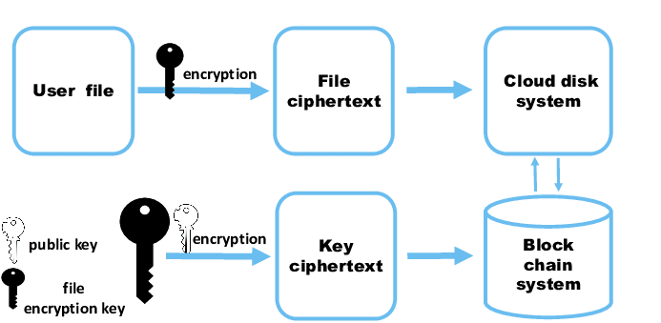

Fig. 2- LEVEL0 DATA FLOW DIAGRAM OF PRODUCT REVIEWS

Diagram Components
- Process:
  - 1.0 Cloud Storage System (Blockchain-based)
- External Entities:
  - User
  - Blockchain Network
  - Decentralized Storage Nodes (e.g., IPFS)
  - Authentication Service / Wallet (e.g., MetaMask)
- Data Flows:
  - Upload file
  - Retrieve file
  - Store metadata
  - Verify access
  - Return file
  - Authenticate user

Textual Description of Data Flow
- User → Cloud Storage System
  - Upload File Request (includes encrypted data, metadata, permissions)
  - Retrieve File Request (file ID, access key)
  - Access Management Request (permission settings)
- Cloud Storage System → Decentralized Storage Nodes
  - Store Encrypted File Chunks
  - Fetch Encrypted File Chunks
- Cloud Storage System → Blockchain Network
  - Record File Metadata (hash, timestamp, permissions)
  - Log Access History
  - Verify Ownership & Permissions via Smart Contract
- Cloud Storage System ↔ Authentication Service
  - Authenticate User (via wallet or key)
  - Return Access Token or Signature
- Cloud Storage System → User
  - Return Confirmation (upload complete, access granted)
  - Return Reassembled File (after successful authentication
.

5.2 System design Flowchart
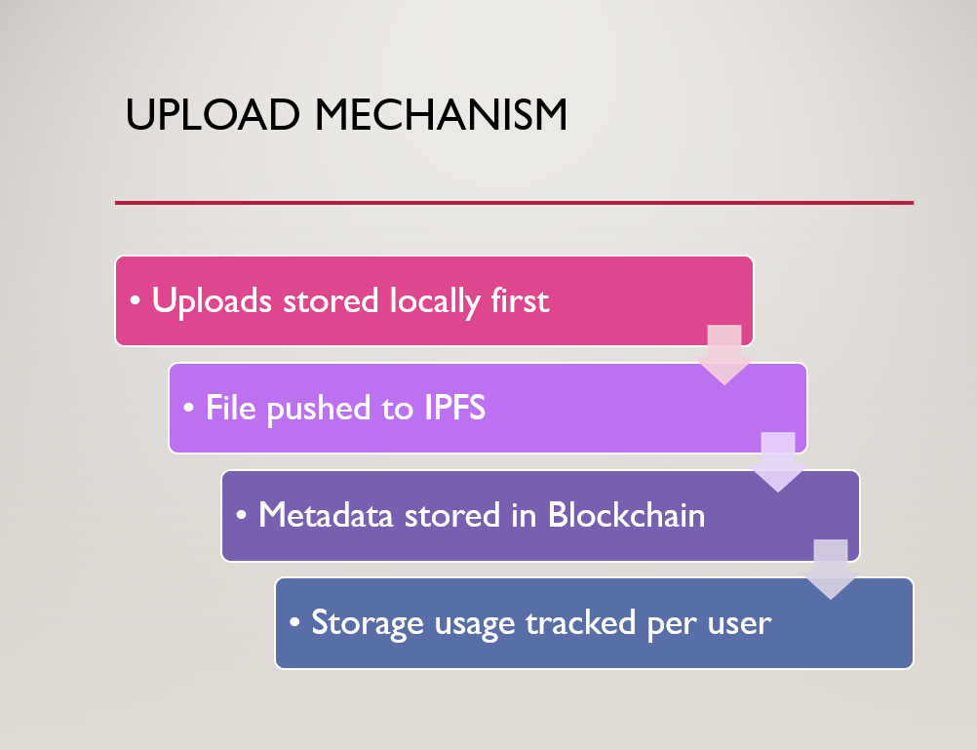

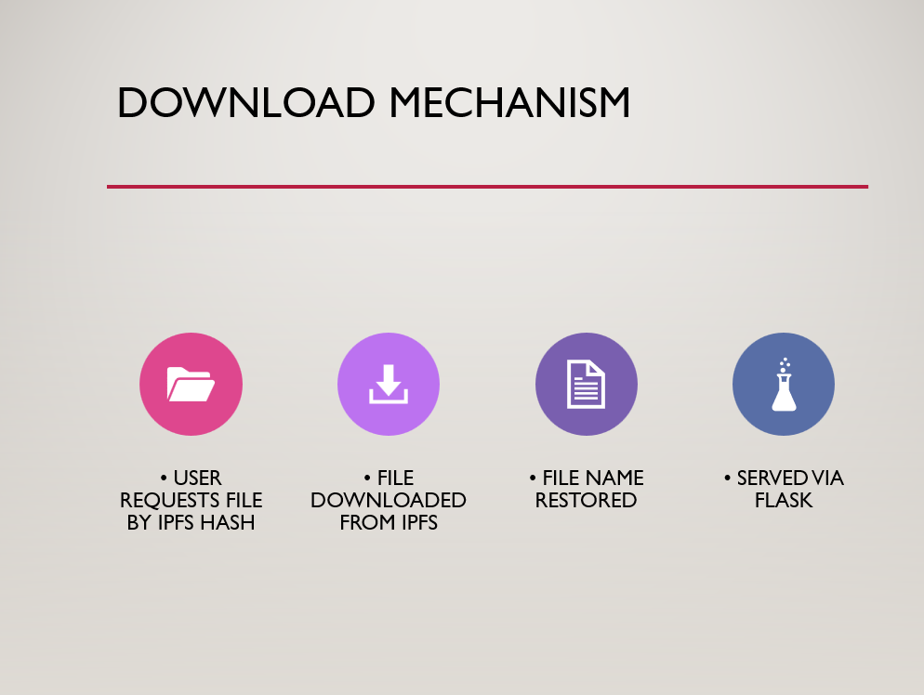

- Initiate the procedure

- The active user presents a request to the system based on search criteria and visitor classifications such as lone, couple, or corporate.

- The system conducts a search in its database for the prior users' data, comprising evaluations, positions, and commentaries that are akin to the request.
- The system sifts the request data by matching it with external web sources.

- Should the request match, the system procures metadata.

- Next, the metadata is archived.

- In case the request does not align, it is discarded.

- Steps 4-7 are repeated until all matched metadata is found. [7]

- Conclude the procedure.

5.5 Output:

The final output of the system includes the interpretation and insights derived from the analysis. This output can be used by educators, policymakers, and stakeholders to make informed decisions regarding student support and educational strategies.

CHAPTER 6
Implementation

6.1 Algorithm
Implementation
Step 1. Blockchain Network (Layer 1 or Custom)
- Stores metadata: file hashes, user ownership, access logs.
- Smart contracts for access control and payments.
Step 2. Off-chain Storage (e.g., IPFS, Filecoin, Storj, Arweave)
- Stores the actual file content.
Step 3. Smart Contracts
- Manage file ownership.
- Handle payments, versioning, and access rights.
Step 4. Client Application
- User interface for uploading/downloading.
- Encrypts/decrypts files locally.
- Interacts with blockchain and storage layers.

CHAPTER 7
RESULT
RESULT

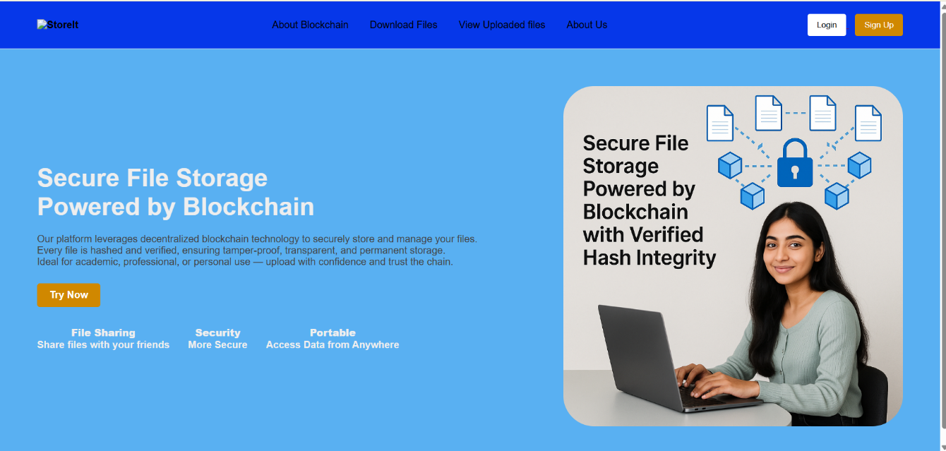
7.1 Output
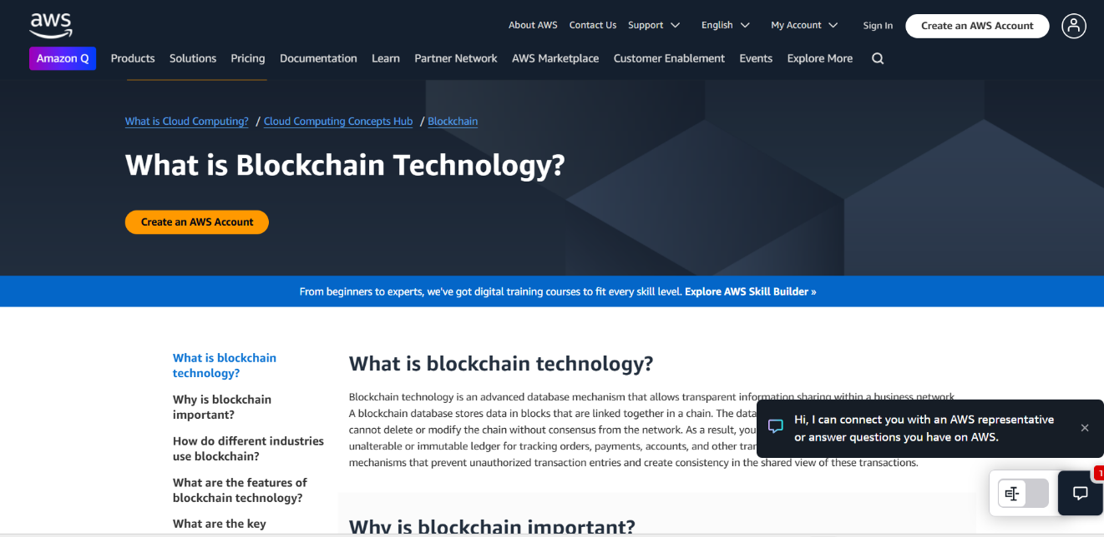

Fig. 7.1.1 Webpage

Fig. 7.1.2 Introduction to Blockchain
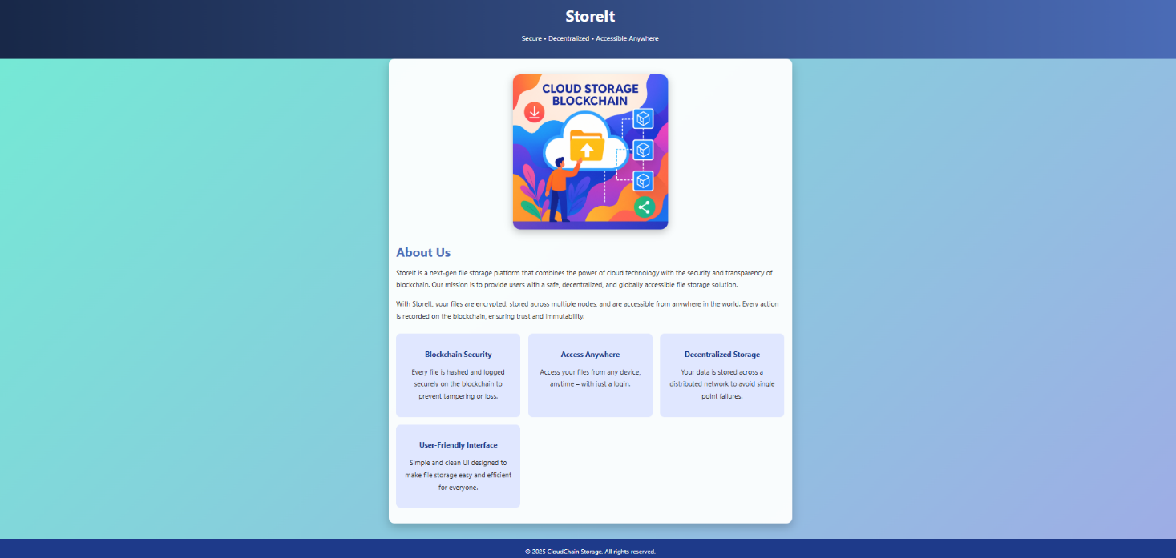
Fig. 7.1.3 About Us

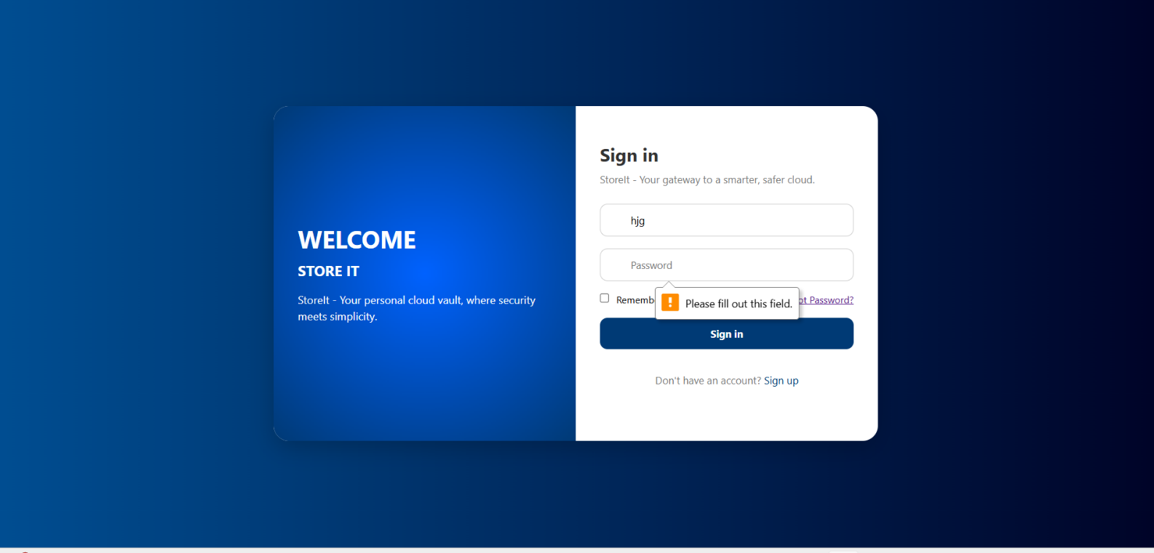
Fig. 7.1.4 Sign in page

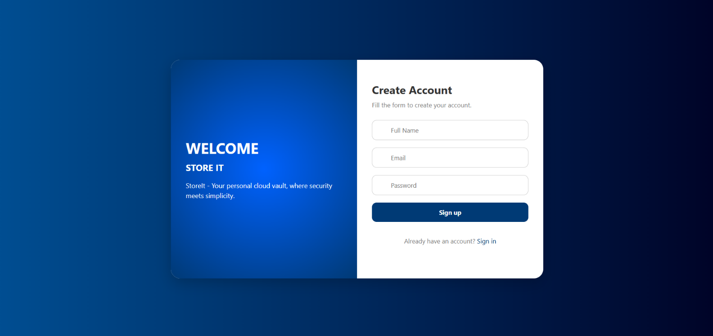

Fig. 7.1.5 Sign up page

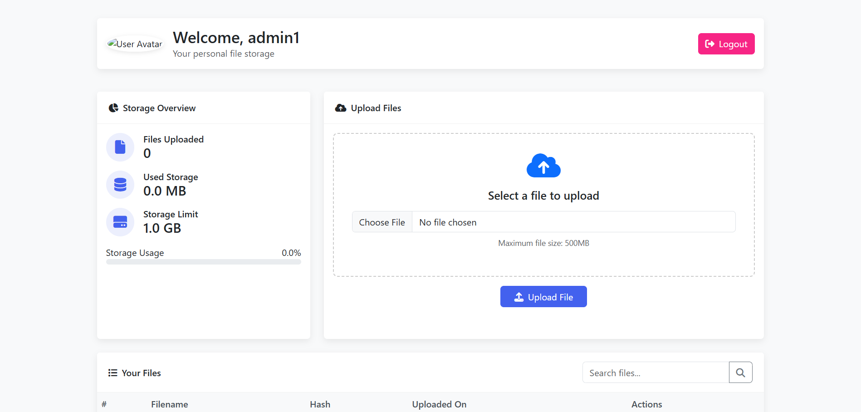

Fig. 7.1.6 Dashboard

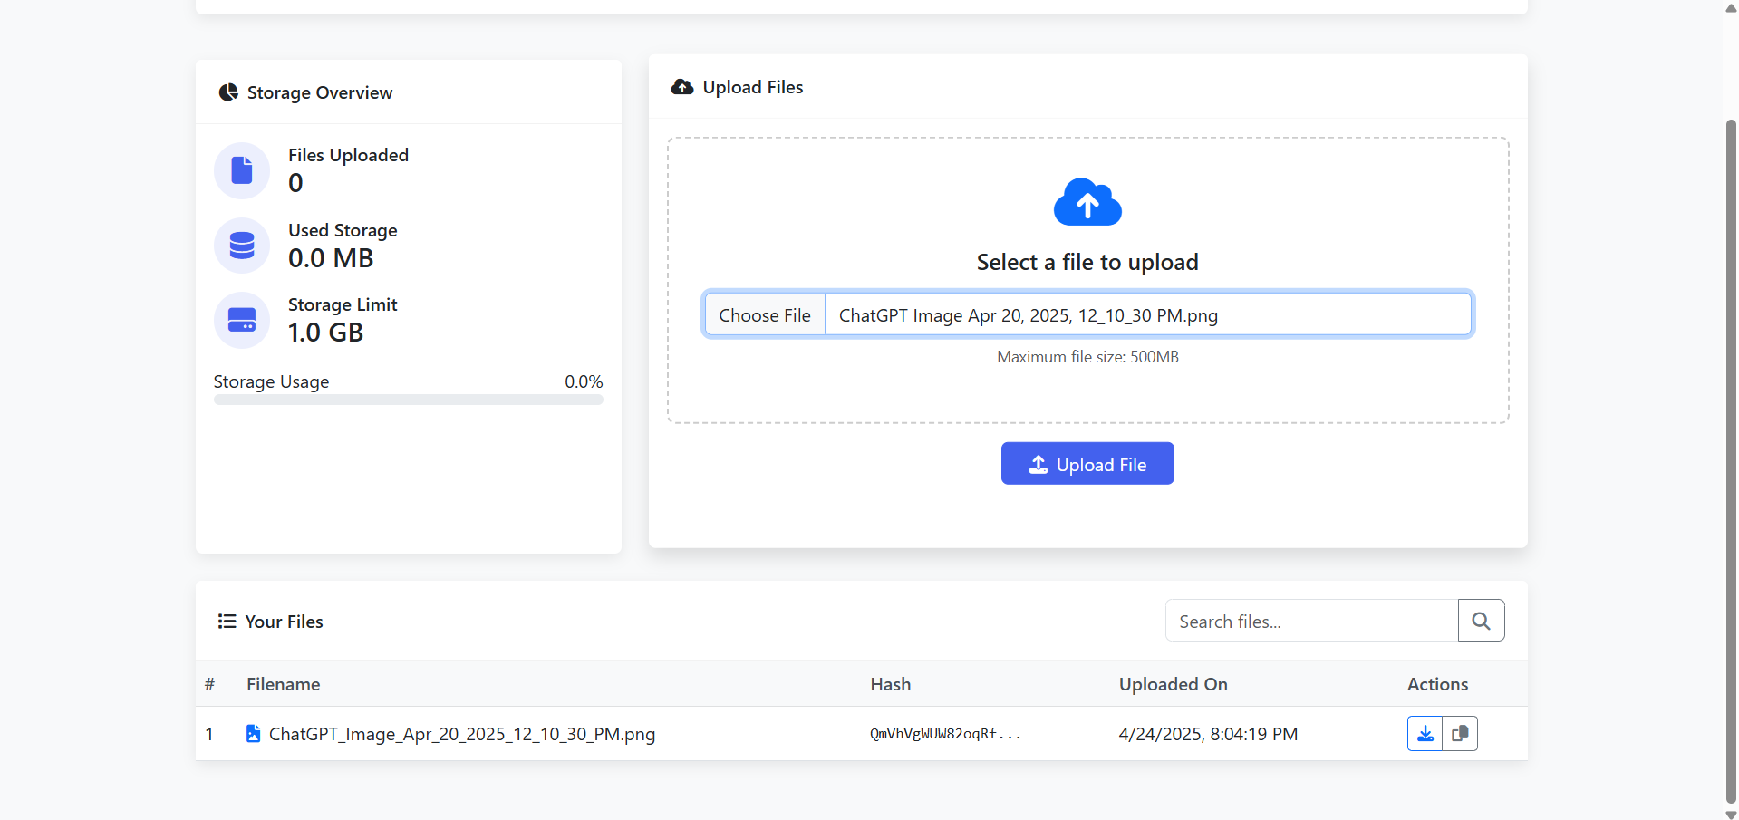

Fig. 7.1.7 File Uploading

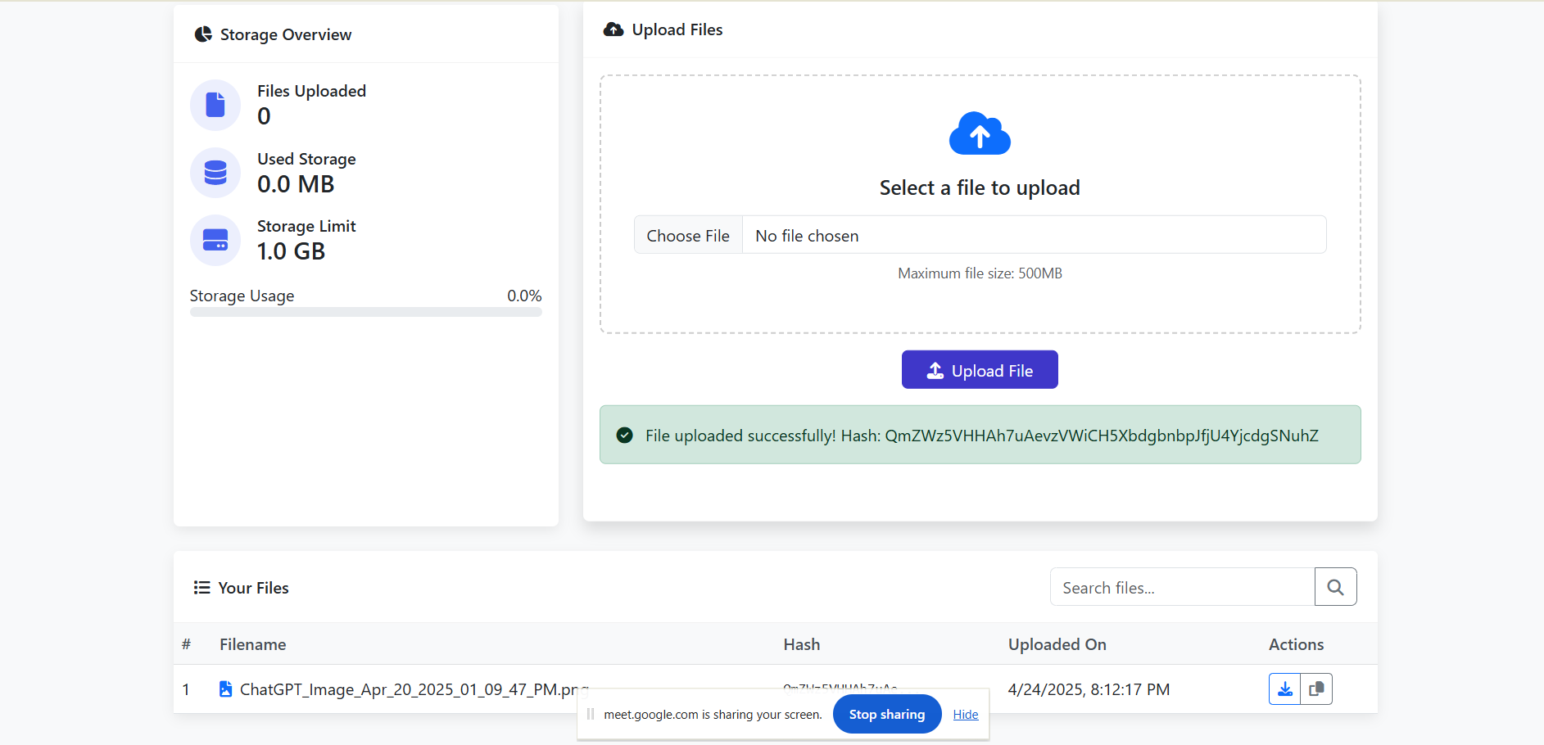

Fig. 7.1.8 File Uploaded

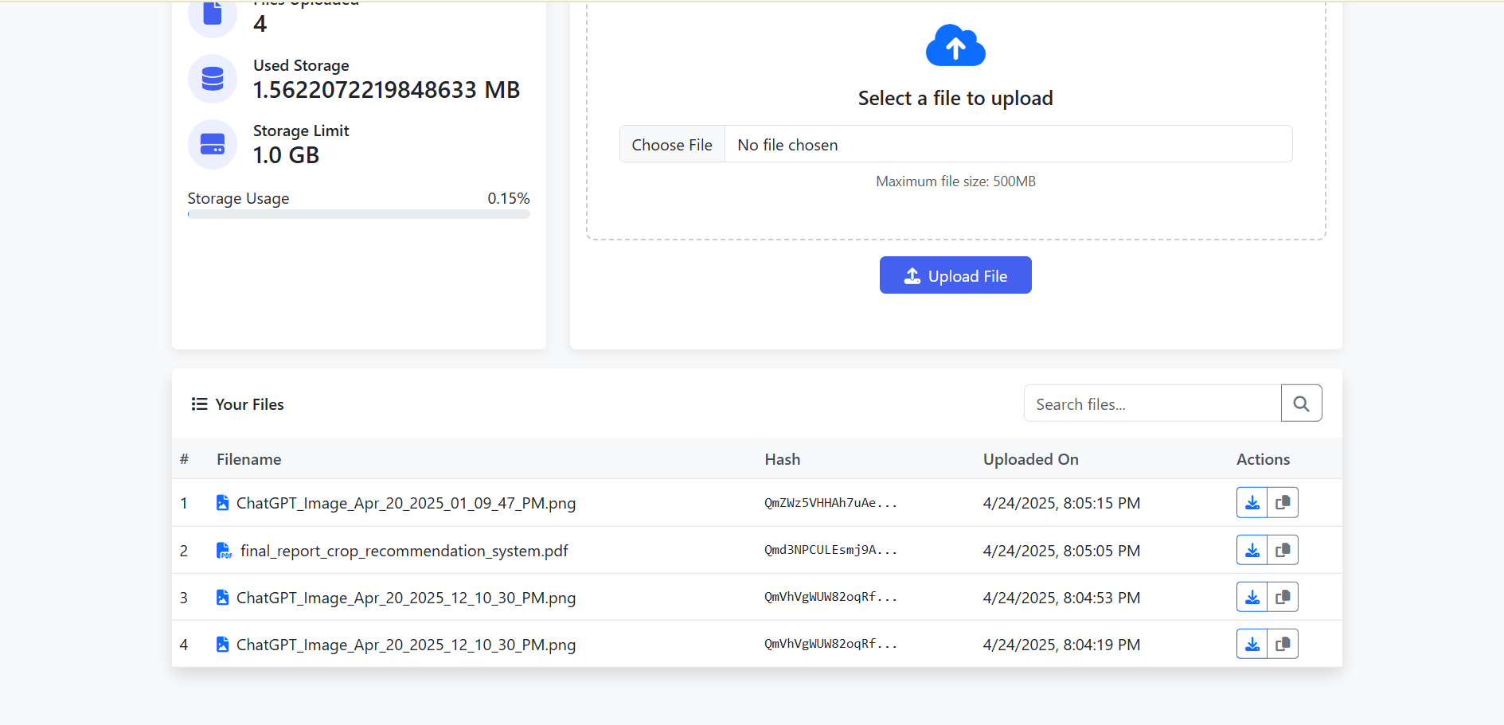

Fig. 7.1.9 More files Uploaded
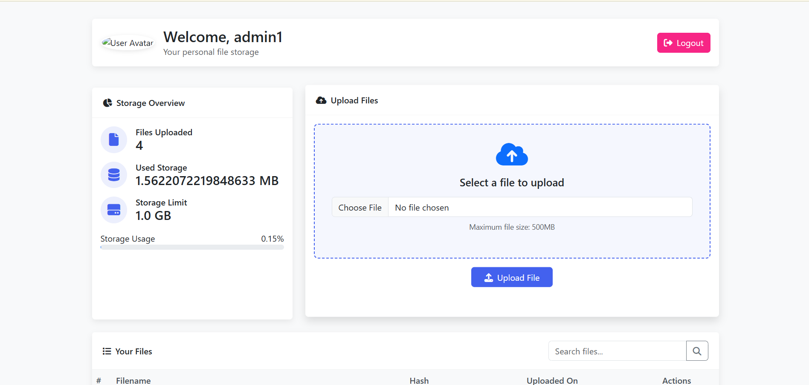

Fig. 7.1.10 Updated Dashboard

CHAPTER 8 FUTURE SCOPE AND CONCLUSION

  - Conclusion:

CONCLUSION
The proposed system implements a decentralized peer-to-peer (P2P) file storage network where each participating node can contribute to storage and retrieval operations. By integrating IPFS for distributed storage and a custom blockchain for immutable metadata recording, the system ensures high availability, tamper-proof storage, and enhanced user privacy. The project leverages key cryptographic algorithms for secure file handling and bcrypt hashing for user authentication, creating a robust environment for both secure file storage and file verification.

Smart contracts can be introduced to automate agreements between service providers and clients, while ERC20 tokens (or similar) can serve as a future payment mechanism for incentivizing storage contributions. Although the current implementation focuses on core functionality, the architecture is modular, allowing different layers to be reused or extended for various use cases, including document verification, secure backups, and decentralized applications (dApps).

The project provided an exciting opportunity to explore real-world applications of Blockchain, IPFS, and Cryptography, reinforcing both theoretical and practical skills. However, like any system, there is room for further improvement and feature enhancement. Future enhancements could include:
- Developing a web-based client interface alongside the mobile or desktop app.
- Enabling support for larger files with improved encryption, sharding, and merging capabilities.
- Introducing a compensation mechanism for faulty or non-performing nodes, possibly through smart contract arbitration.
- Exploring the use of a central authority or a randomly selected third-party auditor node for conflict resolution.
- Fine-tuning cryptographic algorithms and network protocols for better efficiency, scalability, and security.

FUTURE SCOPE

The development of this decentralized cloud storage system opens the door for numerous enhancements and innovative use cases. As the technologies of Blockchain, IPFS, and Web3 continue to evolve, the system can be expanded and refined in the following ways:

- End-to-End Encryption: Implementing full end-to-end encryption will ensure that only the file owner can decrypt and access the data, even if it is stored across public IPFS nodes.

- Smart Contract Integration: Future versions can incorporate smart contracts (e.g., on Ethereum or Polygon) for automatic payment settlements, user access control, and service-level agreements.

- Token-Based Incentives: A token economy (using ERC20 or similar) can be introduced to reward users for contributing storage space, enhancing system participation and scalability.

- Mobile App Support: While a web interface is functional, adding support for Android and iOS mobile apps would improve accessibility and user experience.

- File Sharing & Access Control: Advanced sharing features like read/write permissions, link expiration, and secure public/private sharing could be developed.

- Decentralized Identity (DID): Integrating decentralized identity systems could provide secure login and identity management without relying on traditional authentication methods.

- AI-Based Storage Optimization: Machine learning algorithms could be used to optimize file distribution across the network, improving speed and resource utilization.

- Audit Logs & Compliance Tools: Tools can be developed for organizations to meet compliance standards like GDPR, by maintaining transparent and immutable access logs.

- Multi-Chain Support: The system could be extended to support various blockchains (e.g., Solana, Avalanche, BNB Chain) to improve interoperability and transaction efficiency.

REFERENCES
1. Crosby.M, P. Pattanayak, S. Verma, and V. Kalyanaraman, “Blockchain
technology: Beyond bitcoin,” Applied Innovation, vol. 2, pp. 6–10, 2016.
2. David Vorick et al. Sia: Simple Decentralized Storage. 2014.
3. Eli Ben-Sasson et al. Zerocash: Decentralized Anonymous Payments from
Bitcoin.2014.
4. Jin Sun et al. Blockchain-Based Secure Storage and Access Scheme for
Electronic Medical Records in IPFS.IEEE.2014.
5. Juan Bernet.IPFS - Content Addressed, Versioned, P2P File System.2014.
6. King.S - Ppcoin: Peer-to-peer crypto-currency with proof-of-stake.2014.
7. McConaghy.T, R. Marques, A. Müller, D. De Jonghe, T. McConaghy, G.
McMullen,R. Henderson, S. Bellemare, and A. Granzotto, “Bigchaindb: a scalable
blockchain database,” white paper, BigChainDB, 2016
8. Nakamoto S. Bitcoin: A peer-to-peer electronic cash system. Consulted, 2008.
9. Shawn Wilkinson et al. Storj: A Peer-to-Peer Cloud Storage Network. 2016.
Vitalik Buterin.Ethereum: A next-generation smart contract and decentralized
platform.2013

ACKNOWLEDGMENT
A T.E. project requires the cooperation and direction of many people. We consequently believe that thanking everyone who supported us in this end eavour is our top priority. We would like to express our gratitude to Dr. Sunil Chavan, our principal, for inspiring us and supplying us with the necessary materials while we worked on this project. Additionally, we would like to thank Dr. K.T. Patil, the department's Head of Computer Engineering, for his gracious cooperation. It is with great pleasure that we thank Prof. Revti Jadhav, our project guide, for her constructive and motivating feedback during the project's planning process as well as for consistently guiding us and offering us insightful information. Last but not least, we want to express our gratitude to our friends, the teaching and non-teaching staff, whose support and advice allowed us to improve our S.E. project. We also appreciate our parents' unwavering help and well wishes.

